Collections deals with arranging the data in the main memory. That data is used by the Java Program.

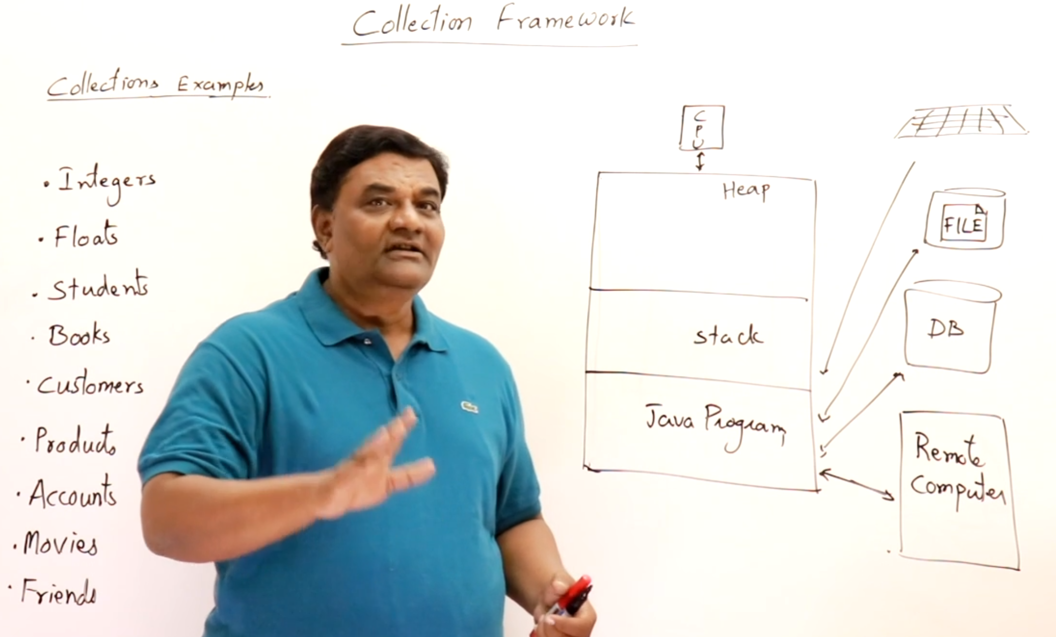

Collection classes and interfaces are generic. They support the object of any class.

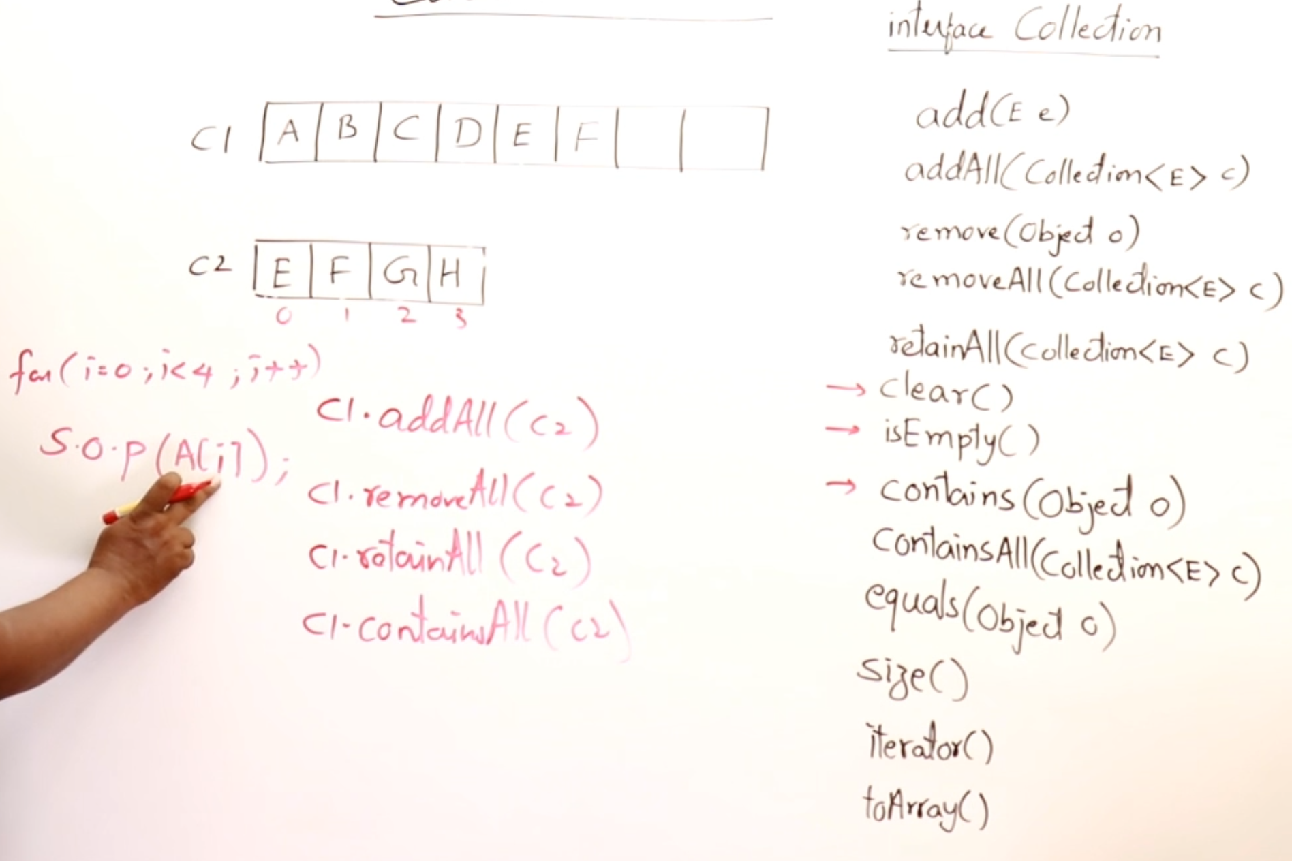

C1.removeAll(C2)   
From C1, only E and F will be removed.

C1.retainAll(C2)

Delete all the objects in C1, just retain only the C2 objects in C1.  
Then only E,F will be present.

# **List Interface 🡪 Not-unique and ordered**

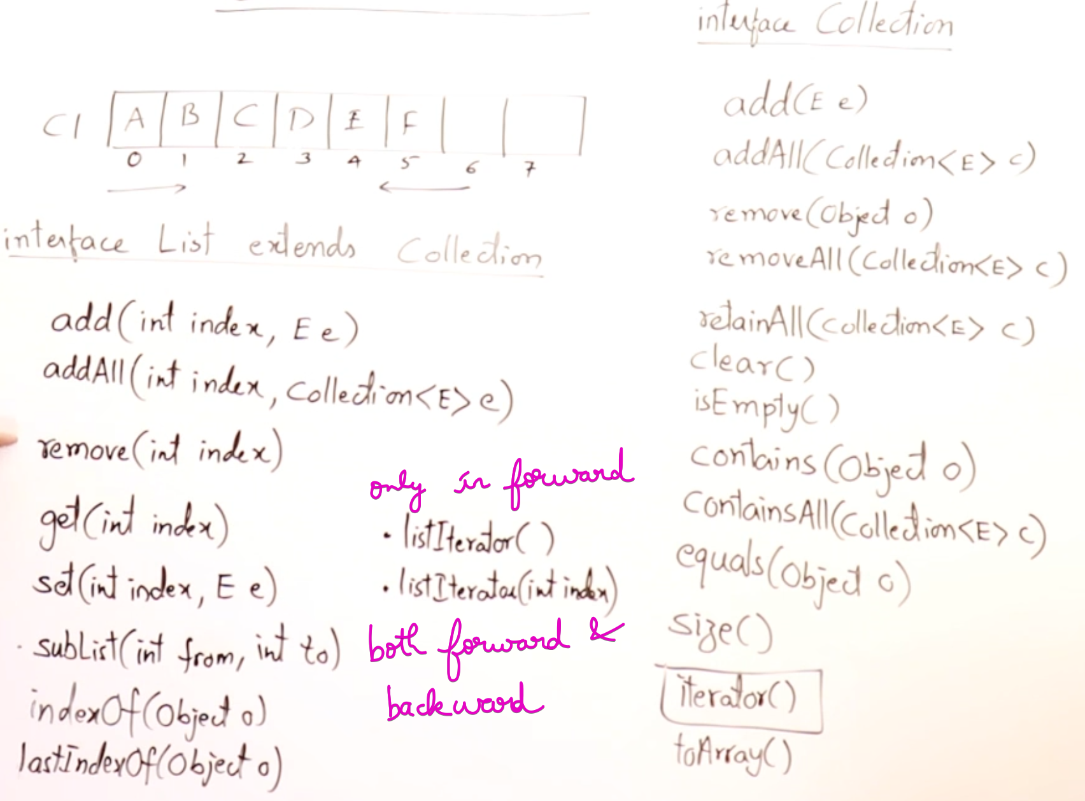

# **Set Interface 🡪 Unique and Un-ordered**

# **Queue Interface**

# 